The Black Plague - Instructions
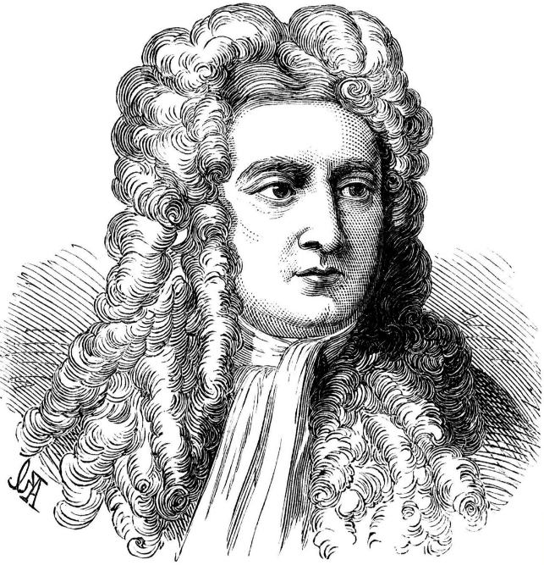
When Isaac Newton was at Cambridge University, the university had to shut down because of an outbreak of the plague.

Let’s assume that Newton went on a trip during this time and visited the following towns and cities:

- Cambridge
- Oxford
- Bristol
- London
- Maidstone
- Canterbury
- Maidstone
- London
- Cambridge

During the time of the plague as much as 20% of London’s population died as a result of the plague.
- Plain Popsticks = Survival – no plague has been contracted
- Red or Orange Popsticks = Plague is contracted
- Your group’s coloured popstick = Plague is spread

Instructions:
Each player takes a turn trying to make the entire journey. The first player starts off in Cambridge: they roll the die.
- A roll of 1, 2 or 3 = One night stay in the town.
- A roll of 4, 5, or 6 = Two night stay in the town.

Without looking in the bag, pull out 1 or 2 popsticks for the number of nights staying in the town. (Place the popsticks back in the bag). If a plain popstick is pulled the player will continue on their journey to the next town. If a red popstick is pulled (return to the bag) the player will continue for the next two towns they visit before they die from the plague.

Onto the next town:
- A roll of 1, 2, or 3 means the player places 1 coloured plague popstick in the bag.
- A roll of 4, 5, or 6 means the player places 2 coloured plague popsticks in the bag.

The player continues to the second town, rolls the dice and places one or two popsticks in the bag and then “dies of the plague”. Their trip (and turn) has ended.

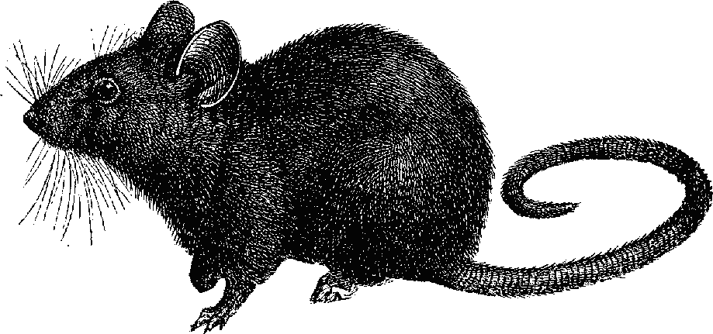
Now it’s the second player’s turn – again starting in Cambridge and trying to make it as far along as they can without contracting the plague and spreading it.

